Marks obtained:

Total:
30
MONTHLY TEST FEBRUARY-2020
Name: ____________________________
Grade: I Section___
Subject: ENGLISH
Date:
Time: 1 Hour
I. Choose the correct answer. 10x1=10
1. The little star shines like__________ diamond.
a. an b. a c. and
2. Insects have __________ legs.
a. three b. four c. six
3. A cow has ______________ horns.
a. four b.two c. one
4. __________ owl and a cat are in the boat.
a. or b. an c. a
5. There is ___________ hut near the beach.
a. an b. in c. a
6. A surprise visit by a family member living faraway________________
a. sadness b. anger c. happiness
7. The leaf is ______________ and soft.
a. green b. hard c. sweet

8. I am a farmer. I work in a______________
a. school b. hospital c. field
9. A picnic or an outing is cancelled because of rain.________________
a. fear b. anger c. sadness
10. There are many storybooks in our ____________________
a. garden b. library c. zoo
II. Write the plural forms for the singular nouns below. 5x1=5
11. beach ___________________
12. pet ___________________
13. light ___________________
14. gift ___________________
15.horse ___________________
III. Match the words to make sentences. 5x1=5
16. Sonam goes sing
17. I have a looked like dinosaur
18. A bird can to library
19. Crocodiles morning
20. It is blue bag
IV. Write true or false. 5x1=5
21. Sonam wants the princess bag.________________
22. Chitra loved the snakes. _______________
23. Red light says go.____________
24. Monkeys were not eating peanuts._______________
25. Sonam wanted Poppy to have the new bag.___________

V. Picture Comperhension.

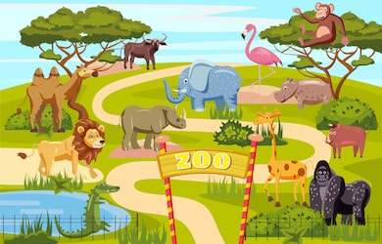
26. Write any two animals name from the picture. (2)
__________________
___________________
27. Write three sentences about the picture. (3)
____________________________________________________________________________________________________________________________________________________________________________________________________________________________________________________________________________________________________________________________________________________________________________________

